04th April 2017

FIA WTCC 2017 Season Opener in Morocco

With a few days to go for the season opener at the FIA World Touring Car Championship, and following the arduous preparation from drivers, teams and mechanics over the past months, this year’s Championship, which has YOKOHAMA, the Japanese premium tyre manufacturer once again as exclusive tyre supplier, is probably one of the most open and exciting in the past years.

With some classic returns to historical Motorsport locations, namely Monza and Macao, and following the departure of the dominant Jose Maria Lopez to another series, and the retirement as a driver of the WTCC - the four times World Champion Yvan Muller, the field is wide open for new blood to take the reins, without ignoring the real chances of the “veterans” in the fray – namely Huff, Monteiro, Michelisz, Coronel and Chilton among others.

Young blood, new team partnerships and the thousands of fervent fans supporting home favourite Mehdi Bennani also in contention, the street circuit in the heart of Marrakech, which was transformed to semi-permanent race track for 2016, the Circuit Moulay El Hassan will offer the thrills and spills of racing, together with impressive views of the Atlas Mountains and the historical Marrakech city wall.

With no chance to bat an eyelid whilst at the wheel of the fast cars in the Championship and a compact lap of 2.9Km with some tight, wall-lined turns, the action is guaranteed.

Commenting on the new season a spokesman for YOKOHAMA Europe expressed excitement with the new Championship and calendar returns to Monza and Macau and wished all drivers and teams the very best of luck. “We are ready, our Motorsport support team is ready and YOKOHAMA as a Global premium Tyre manufacturer is looking forward to an intense World Championship.” Added the Spokesman.

Drivers to watch out for;
Rob Huff - Thiago Monteiro - Norbert Michelisz - Tom Chilton - Mehdi Bennani - Thed Björk - Nicky Catsburg - Nestor Girolami

FIA WTCC Race Calendar 2017
1. Morocco / Marrakech 09 April
2. Italy / Monza 30 April
3. Hungary / Budapest 14 May
4. Germany / Nürburgring 27 May
5. Portugal / Vila Real 25 June
6. Argentina / Termas 16 July
7. China / Ningbo 15 October
8. Japan / Motegi 29 October
9. Macao / Macao 19 November
10. Qatar / Losail 01 December

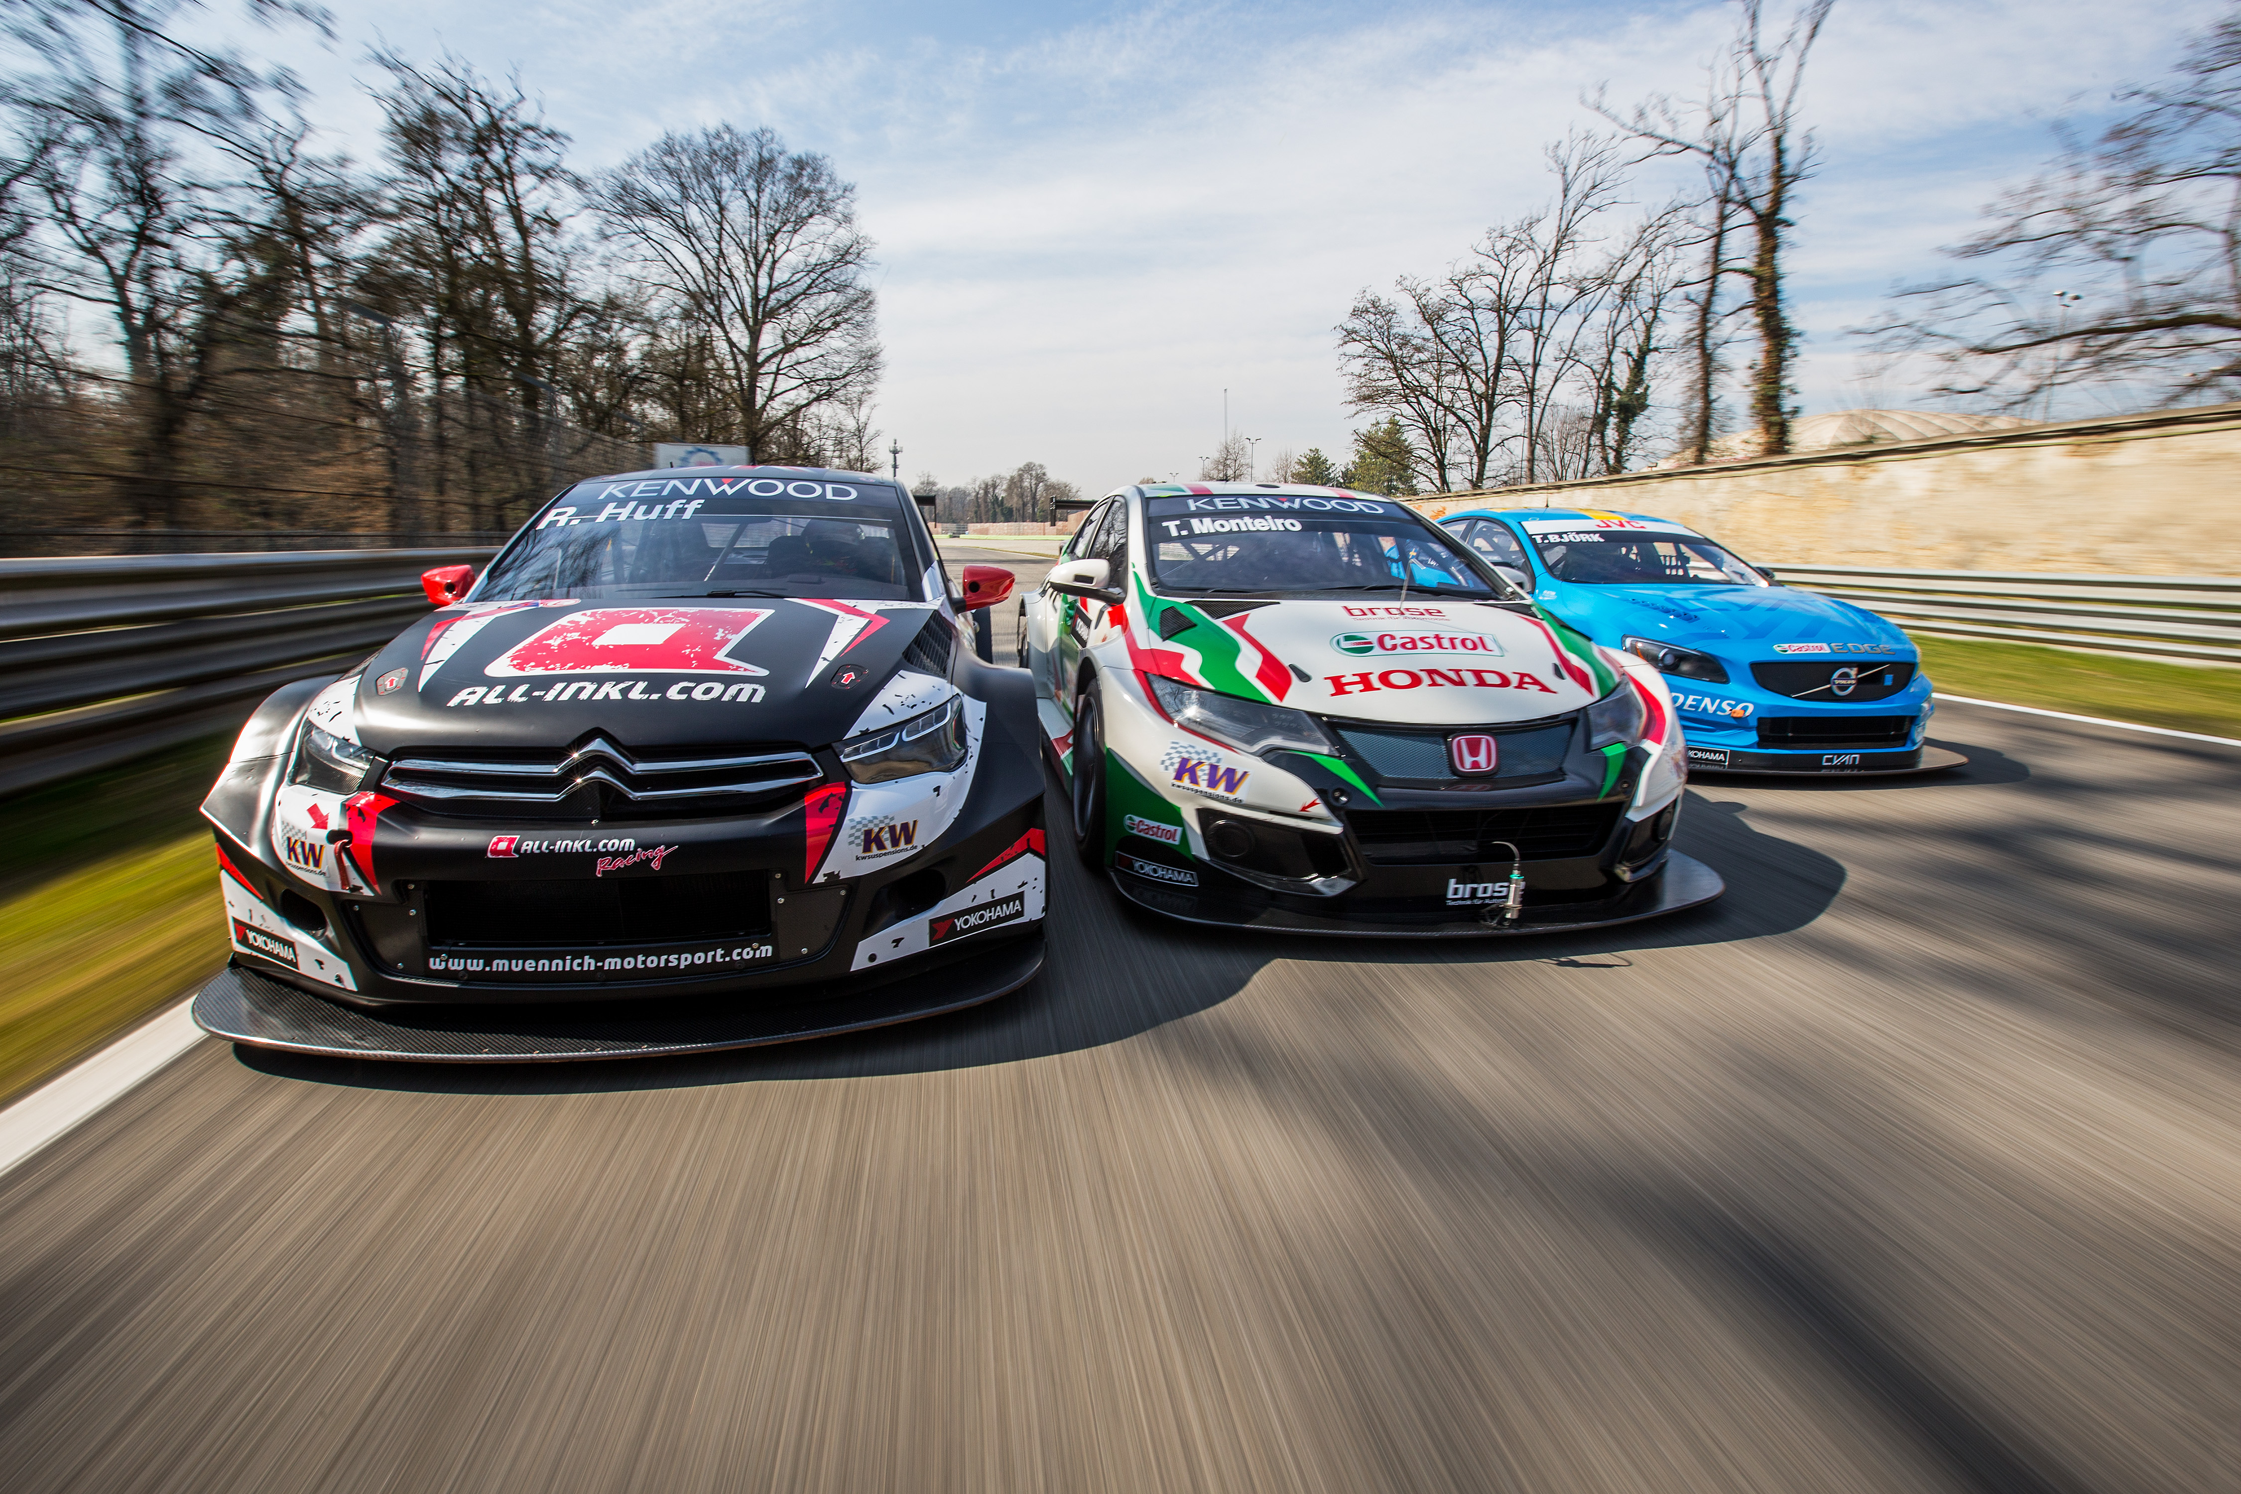
FIA WTCC recent Test at Monza photo Francois Flamand DPPI

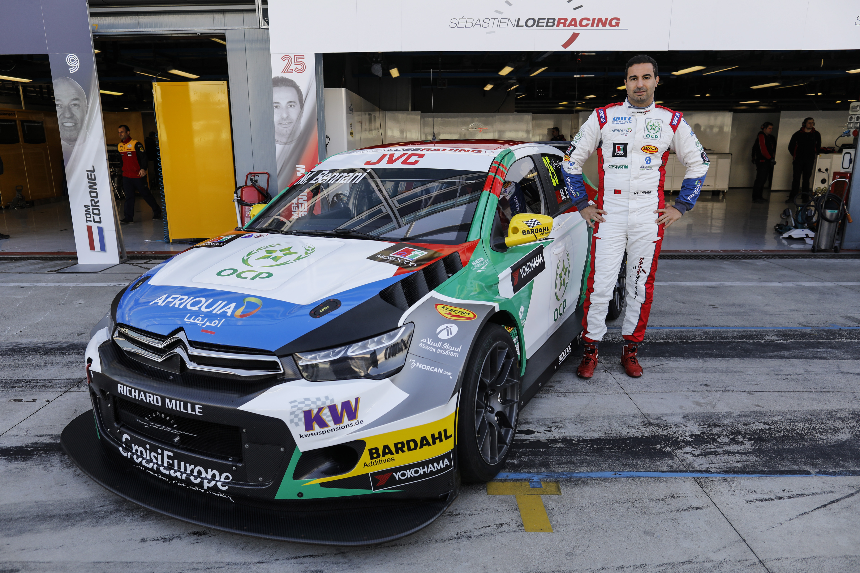
Big hope for Mehdi Bennani at home photo Francois Flamand DPPI

